

TBC Management After a Winter Layoff

Monthly Management

January 2022

www.drinagh.com





For spring calving herds, some TBC issues can arise in the first collections following a winter layoff. To avoid high TBC readings, it is recommended to carry out a weekly hot wash on both the milking machine and bulk tank using the usual detergent used for routine washing. By doing this, good hygiene is maintained, and bacterial growth is greatly inhibited over these weeks. Other important measures to be carried out at this time of year include:

* Checking correct water temperature and volume.
* Automatic washing systems and bulk tanks should be calibrated to ensure the correct amount of detergent and water are used.
* Storage of detergents - products should be stored as directed on the label. Some detergents can crystalize which can reduce cleaning effectiveness and may also block pumps.

Wash Routine When Milk Supply Resumes

The following wash routine can be applied if TBC issues arise upon milk supply resuming. This routine is recommended for the removal of bio-films and other stubborn residues that may have developed in the weeks that the milking machine was idle.

|  |
| --- |
| **Morning** |
| 1. After milking is complete, drain milk and rinse the milk line with **lukewarm** water. |
| 1. Circulate with hot detergent for 7-8 minutes. |
| 1. Rinse the plant with cold water |
| **Evening** |
| 1. After milking is complete, drain milk and rinse the milk line with **lukewarm** water. |
| 1. Circulate with warm descaler for 7-8 minutes (NB do not use very hot water) |
| 1. Rinse the plant with cold water |

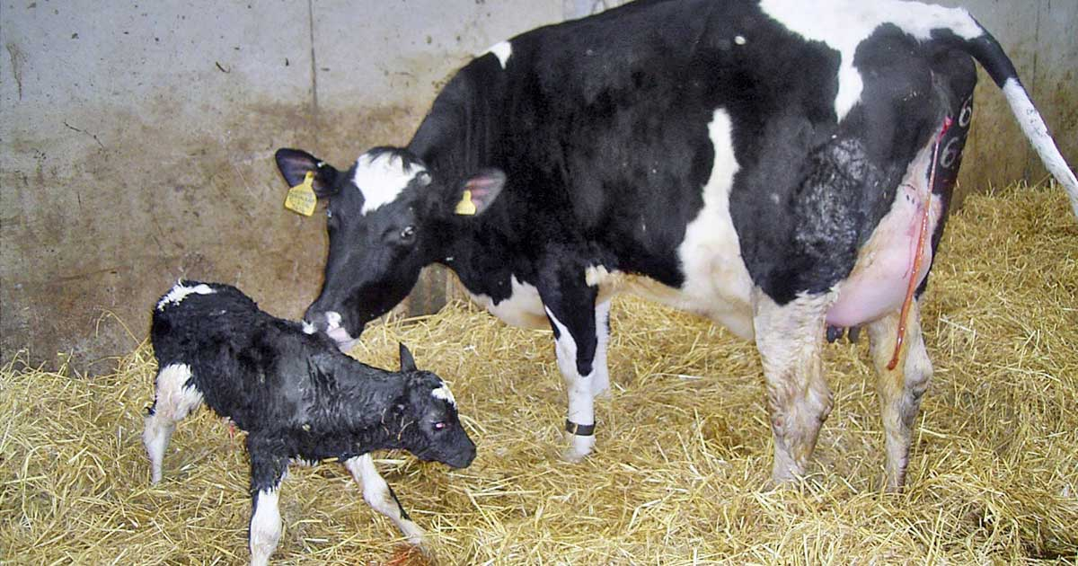

With calving season soon approaching, it is worth reminding ourselves of the importance of colostrum. When born, the calf’s immune system is not fully developed, and the calf depends on the immunity provided by the antibodies in colostrum for protection against disease. The level of antibodies is highest in the first milking and drops significantly in the second and third milking.

|  |  |  |  |  |
| --- | --- | --- | --- | --- |
|  | **Milking Number** | | | |
|
| 1 | 2 | 3 | 11 |
|  | Colostrum | Transition milk | | Whole milk |
| Total Solids, % | 23.9 | 17.9 | 14.1 | 12.5 |
| Fat, % | 6.7 | 5.4 | 3.9 | 3.9 |
| Protein, % | 14 | 8.4 | 5.1 | 3.1 |
| Antibodies, % | 6 | 4.2 | 2.4 | 0.09 |
| Minerals, % | 1.11 | 0.95 | 0.87 | 0.74 |
| Vitamin, ug/dL | 295 | 190 | 113 | 31 |

Antibodies are absorbed through the calf’s intestinal wall reduce dramatically over the first 24 hours of life. Therefore, it is vital that all newborn calves receive colostrum shortly after birth.

|  |  |
| --- | --- |
| **Time** | **Ig Absorption in the Calf** |
| Within 2 Hours | Highest |
| After 6 hours | Reduced by 50% |
| After 12 hours | Reduced by 75% |

The 1,2,3 rule should always apply – first milking, within 2 hours and 3 litres to be fed.

Colostrum Quality

**Sales Reps: Richard Murphy 086 8272057 Agricultural Advisors: Tim Regan 086 8241635**

**David Shiels 087 6863576 Darren Lynch 087 2140715**

*Join us on the January 25th for the Spring Dairy Webinar to hear Dr. William Burchill of Teagasc discuss ways of using slurry to grow grass in 2022*

|  |  |  |
| --- | --- | --- |
| Rate per acre | Application Method | N units per acre |
| 2,000 gals | Trailing shoe/dribble bar | 21 units |
| 2,500 gals | Trailing shoe/dribble bar | 27 units |
| 3,500 gals | Trailing shoe/dribble bar | 37 units |
| 2,500 gals | Splash plate | 20 units |
| 3,500 gals | Splash plate | 28 units |

**Table 1.1**

1. **Know what’s in your slurry and adjust your application rate to suit**

Slurry can be tested for its N, P, K and dry matter content relatively easily. Teagasc carried out tests over a large number of samples in the winter of 2020/2021. The slurry samples tested contained 10.7 units N/1,000 gals (applied using LESS in spring), 5.3 units P and 27 units K per 1,000 gals on average.

Based on these results, slurry applied in the spring (highlighted in Table 1.1 below) will provide the following amount of N depending on application technique.

The value of slurry has essentially doubled in the last twelve months due to the increase in fertiliser costs and now stands at around €40 per 1,000 gals of cattle slurry. With this in mind here are 3 steps to maximise the use of slurry on you farm in 2022;

1. **Apply slurry to silage ground to maximise its P and K value**

There is a big temptation to use more slurry on the milking platform in 2022 in order to reduce nitrogen costs on this part of the farm. However, we need to remember that the majority of the value of slurry is from its P and K and thus slurry should be targeted to areas of the farm with the highest demand for P and K i.e. silage ground. When spreading slurry on the milking platform target paddocks with low P and K indexes first and the lowest grass covers in spring. Trailing shoe and dribble can be used to apply slurry to paddocks with covers less than 1,000 kg DM/ha.

On dairy farms that finish their first round of grazing in early April the standard N recommendation in spring is to apply 23 units N/acre in late January/early February once ground and growth conditions are suitable.

Based on this recommendation and the results of the slurry tests we can see that using a trailing shoe/dribble bar at a rate of 2,000-2,500 gals/acre will be the most efficient method to replace the standard ½ bag urea or 23 units N/acre to reduce your fertiliser N cost this spring.

Using heavier applications of slurry with a trailing shoe/dribble bar will supply more N than is required at this time of the year. Instead of going at a heavier rate it would be much more suitable to apply the slurry over a larger area or hold that slurry until more land becomes available. Where paddocks have too high a cover for slurry at the moment these higher covers could be targeted with 20-23 units of urea in the coming weeks and may be an option for slurry after the first grazing in late February / March.

**3. Apply slurry in spring using dribble bar or trailing shoe to maximise its N value**

Changing slurry applications from the summer time with a splash-plate to the spring with a dribble bar or trailing shoe will give you an **extra a 6 units of N per 1,000 gals from your slurry**. While spreading slurry in spring has the potential to improve slurry N values, the key is to apply it when grass is actively growing. Given the current value of slurry and outside of the practical need to lower slurry tanks at certain times early in the year we should be asking ourselves if we are reluctant to spreadchemical N fertiliser at stages during the spring due to poor growing conditions should be spreading slurry either if we want to maximise its nutrient value?

Slurry & Fertiliser Planning For 2022

**Drinagh Main Office:** 028-30800 ~ **Skibbereen Hardware:** 028-24200 or 028-21699 ~ **Central Hardware** Saturdays: 028-30920 ~ **Bantry Hardware** 027-55388 ~ **Dunmanway Hardware**: 023 8856646~ **Bantry** **Farm Centre**: 027-52172 ~ **Lowertown Hardware**: 028-28117 ~ **Kilmeen**: 023- 8838603~ **Aughadown**: 028-38113~ **Castletownbere**: 027-70003

Monthly Management

January 2022

2015